Sơ đồ dịch chuyển màn hình

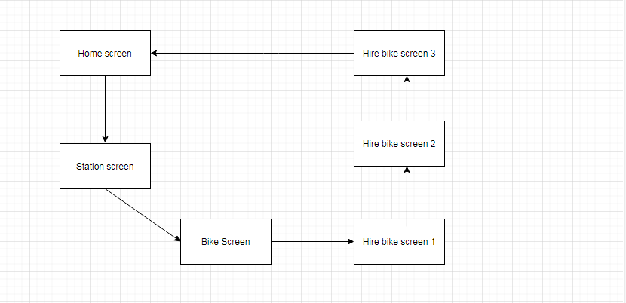

Mô tả màn hình Bike Screen

|  |  |  |  |  |  |
| --- | --- | --- | --- | --- | --- |
| RentalBike | | Date of creation | Approved  by | Reviewed  by | Person in charge |
| Screen specification | Bike screen | 20/12/2020 |  |  | Bùi Tuấn Anh |
| Bikescreenfx.PNG | | Control | Operation | Function | |
| Area for displaying bike station details | Initial | Display bike station details | |
| Area for displaying bike details | Initial | Display bike details | |
|  |  |  | |
|  |  |  | |

Các trường thuộc tính

|  |  |  |  |  |
| --- | --- | --- | --- | --- |
| Screen name | Bike Screen |  | | |
| Item name | Numberof  digits (bytes) | Type | Field attribute | Remarks |
| Bike type | 50 | String | Black | Left-justified |
| Bike model | 50 | String | Black | Left-justified |
| Battery | 20 | Numeral | Black | Left-justified |
| Price | 20 | Numeral | Black | Left-justified |

Mô tả màn hình Homepage

|  |  |  |  |  |  |
| --- | --- | --- | --- | --- | --- |
| RentalBike | | Date of creation | Approved  by | Reviewed  by | Person in charge |
| Screen specification | Homepage | 20/12/2020 |  |  | Bùi Tuấn Anh |
| Homepagefx.PNG | | Control | Operation | Function | |
| Area for displaying service details | Initial | Display service details | |
| Button for renting bike | Click | Move user to renting page | |
|  |  |  | |
|  |  |  | |

Các trường thuộc tính

|  |  |  |  |  |
| --- | --- | --- | --- | --- |
| Screen name | Homepage |  | | |
| Item name | Numberof  digits (bytes) | Type | Field attribute | Remarks |
| Advantage of service | 50 | String | Black | Left-justified |

Mô tả màn hình Hire Bike Screen 1

|  |  |  |  |  |  |
| --- | --- | --- | --- | --- | --- |
| RentalBike | | Date of creation | Approved  by | Reviewed  by | Person in charge |
| Screen specification | Hire bike screen 1 | 20/12/2020 |  |  | Bùi Tuấn Anh |
| Hirebikescreen1.PNG | | Control | Operation | Function | |
| Area for displaying bike details | Initial | Display bike details | |
| Button for renting the bike | Click | Let user rent the bike | |
|  |  | \ | |
|  |  |  | |

Các trường thuộc tính

|  |  |  |  |  |
| --- | --- | --- | --- | --- |
| Screen name | Homepage |  | | |
| Item name | Numberof  digits (bytes) | Type | Field attribute | Remarks |
| Bike type | 50 | String | Black | Left-justified |
| Bike model | 20 | String | Black | Left-justified |
| Deposit | 20 | Numeral | Black | Left-justified |

Mô tả màn hình Hire Bike Screen 2

|  |  |  |  |  |  |
| --- | --- | --- | --- | --- | --- |
| RentalBike | | Date of creation | Approved  by | Reviewed  by | Person in charge |
| Screen specification | Hire bike screen 2 | 20/12/2020 |  |  | Bùi Tuấn Anh |
| Hirebikescreen2.PNG | | Control | Operation | Function | |
| Area for displaying bike details | Initial | Display bike details | |
| Area for displaying rental timer | Initial | Display rental timer | |
| Button for returning the bike | Click | Let user rent the bike | |
|  |  | \ | |
|  |  |  | |

Các trường thuộc tính

|  |  |  |  |  |
| --- | --- | --- | --- | --- |
| Screen name | Homepage |  | | |
| Item name | Numberof  digits (bytes) | Type | Field attribute | Remarks |
| Bike type | 50 | String | Black | Left-justified |
| Bike model | 20 | String | Black | Left-justified |
| Deposit | 20 | Numeral | Black | Left-justified |
| Timer | 50 | Time | Black | Left-justified |

Mô tả màn hình Hire Bike Screen 3

|  |  |  |  |  |  |
| --- | --- | --- | --- | --- | --- |
| RentalBike | | Date of creation | Approved  by | Reviewed  by | Person in charge |
| Screen specification | Hire bike screen 3 | 20/12/2020 |  |  | Bùi Tuấn Anh |
| Hirebikescreen3.PNG | | Control | Operation | Function | |
| Area for displaying bike details | Initial | Display bike details | |
| Area for displaying rental timer | Initial | Display rental timer for the bike | |
| Area for displaying return bike station | Initial | Display available returned bike station | |
| Button for returning the bike | Click | Confirm returning the bike | |

Các trường thuộc tính

|  |  |  |  |  |
| --- | --- | --- | --- | --- |
| Screen name | Homepage |  | | |
| Item name | Numberof  digits (bytes) | Type | Field attribute | Remarks |
| Bike type | 50 | String | Black | Left-justified |
| Bike model | 20 | String | Black | Left-justified |
| Deposit | 20 | Numeral | Black | Left-justified |
| Timer | 50 | Time | Black | Left-justified |
| Returned bike station name | 50 | String | Black | Left-justified |
| Returned bike staion address | 50 | String | Black | Left-justified |

Mô tả màn hình Station Screen

|  |  |  |  |  |  |
| --- | --- | --- | --- | --- | --- |
| RentalBike | | Date of creation | Approved  by | Reviewed  by | Person in charge |
| Screen specification | Station Screen | 20/12/2020 |  |  | Bùi Tuấn Anh |
| Stationscreen.PNG | | Control | Operation | Function | |
| Area for displaying available bike stations | Initial | Display available bike stations | |
| Area for displaying bike station details | Initial | Display bike station details | |
|  |  |  | |
|  |  |  | |

Các trường thuộc tính

|  |  |  |  |  |
| --- | --- | --- | --- | --- |
| Screen name | Bike station |  | | |
| Item name | Numberof  digits (bytes) | Type | Field attribute | Remarks |
| Bike station name | 50 | String | Black | Left-justified |
| Bike station address | 20 | String | Black | Left-justified |
| Distance to bike station | 20 | Numeral | Black | Left-justified |
| Bike station area square | 20 | Numeral | Black | Left-justified |
| Bike station total bike | 20 | Numeral | Black | Left-justified |
| Bike station available bike | 20 | Numeral | Black | Left-justified |